Project Design Phase
Solution Architecture

Date | 18th June 2026
Team ID
Project Name | Health Connect
Maximum Marks | 4 Marks

Solution Architecture:
Solution architecture is a complex process – with many sub-processes – that bridges the gap between business problems and technology solutions. Its goals are to:
- Find the best tech solution to solve existing business problems.
- Describe the structure, characteristics, behavior, and other aspects of the software to project stakeholders.
- Define features, development phases, and solution requirements.
- Provide specifications according to which the solution is defined, managed, and delivered.

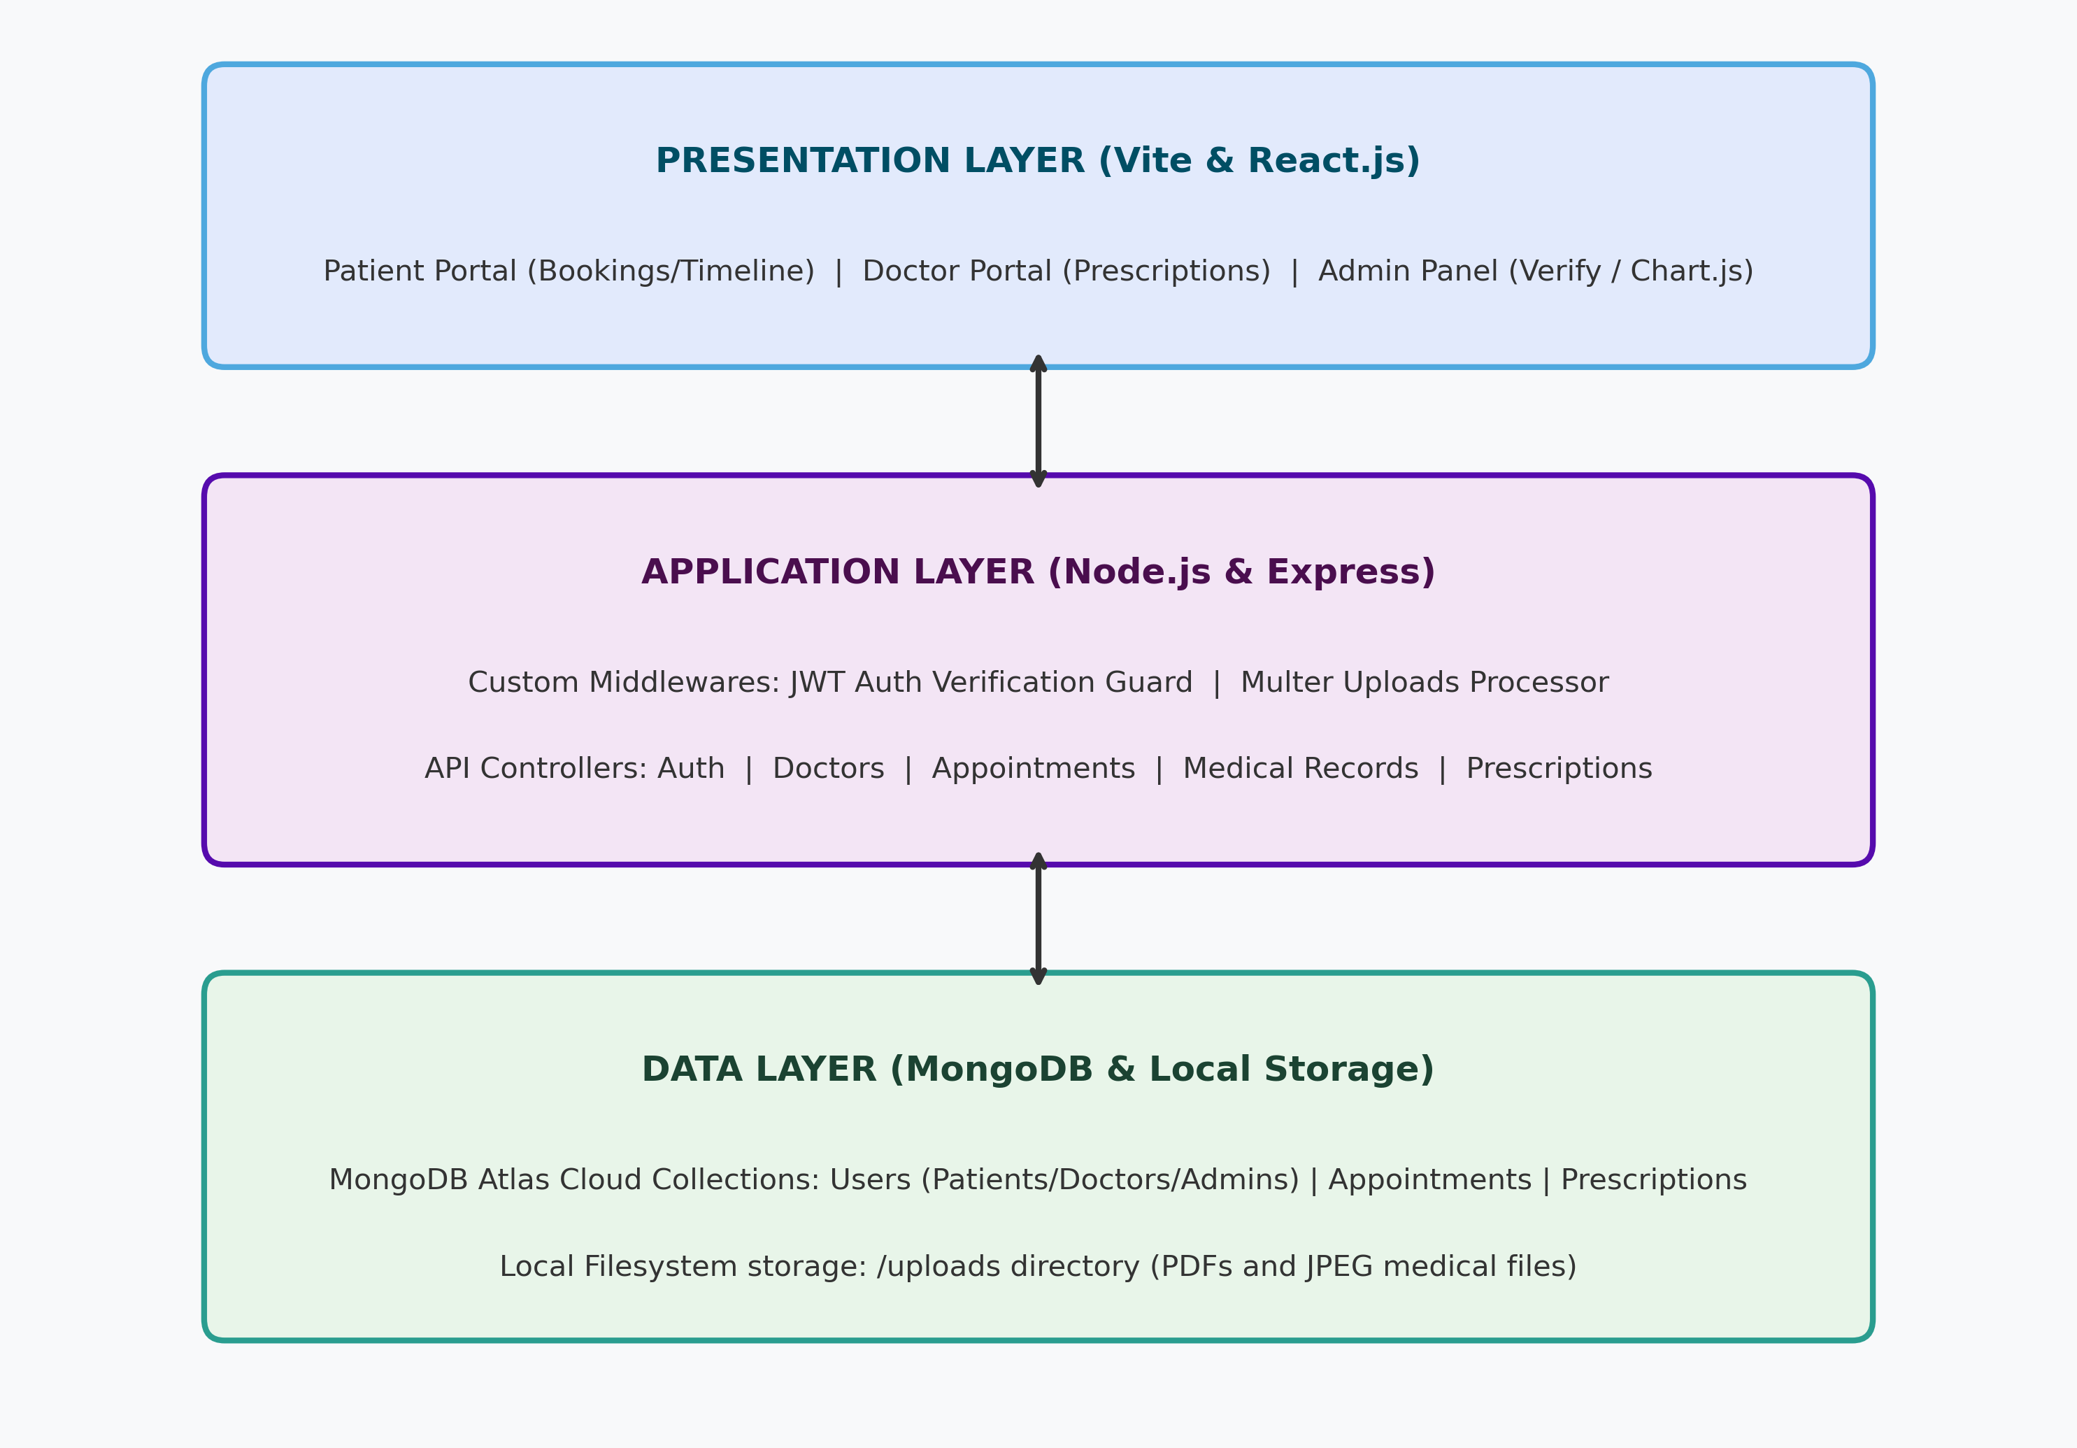


Figure 1: Architecture and data flow of the voice patient diary sample application
## Health Connect 3-Tier Architecture Description
The application follows a standard 3-Tier architecture model to separate concerns:
1. Frontend (Presentation Layer): Built with React, Vite, and Bootstrap 5. It manages state using React Context and makes API requests using Axios. Chart.js is used on the admin portal.
2. Backend (Application Layer): Express.js and Node.js act as the server. It exposes REST API endpoints, utilizes custom JWT middleware for authentication, and processes file uploads locally via Multer.
3. Database (Data Layer): MongoDB storing collections for User, Doctor (with verification state), Appointment (with slots/fees), MedicalRecord (with upload paths), and Prescription.

